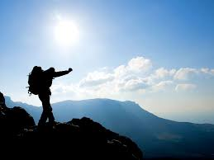
DofE Course
notes

Contents
Section 1 – Navigation 3
Navigational tools 4
Navigating strategy 5
The Compass 6
Magnetic Variation 7
Interpreting contours 9
Relocation when lost 10
Section 2 – Route planning 11
Hazards and route 12
Example route card 13
Section 3 – First Aid 14
Basic First Aid 15
Ticks and Lyme disease 17
Section 4 – Emergency Procedures 18
Emergency procedures 19
Section 5 – The countryside code 21
Countryside Code 22
Section 6 – Kit and Packing 23
Kit list 24
Packing a Rucksack 27
Section 7 – Campcraft 29
Looking after your tents 30
Campsites 31
Wild camping 32
Gas trangia use 33
Section 8 – Nutrition 34
Expedition menu – In principle 35
Expedition menu – In practice 36
Expedition Menu plan 37
20 conditions of the Duke of Edinburgh Award Scheme 38

Section 1 – Navigation

- Navigational Tools

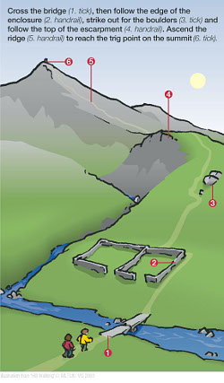
Handrails: These are linear features that you can follow, they include paths, streams, ridges, crags, walls and if it is misty, a compass bearing.
Tick Features: Looking at the map, if you mentally move along a handrail make note of all the things you are going to pass. You may cross a wall, pass a tarn and end up at a sheepfold. All these points are tick features. Identifying tick features and mentally ticking them off as you walk past them is the key to fair weather navigation. Be careful though as the wall may have fallen down the tarn may be dry and the sheepfold may have been dismantled.
Catchments: This is another name for a tick feature at which you have to stop to make a decision on where to go. For example, at a path junction.
Overshoots: If you miss your catchment (or if no catchment existed) then you may end up further along your handrail than intended. Having identified an overshoot (a recognisable, distinct, tick feature) further along the handrail you will hopefully notice that you’ve gone too far and can start to back track.
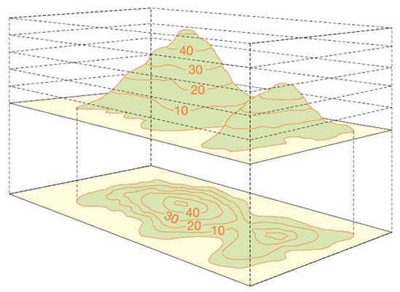
Contour lines: Contour lines are used in mapping to represent the shape of the land. By interpreting them we get a three dimensional representation of what the terrain will look like. Each contour line connects different areas on the map that are at the same height above sea level. When planning your expedition, contour lines tell you if you will be going up or down hill and how steep the slope will be. It is hard to overstate the importance of contours when navigating using a map. It is often said that they are the only thing that you can really rely on when reading a map. Walls deteriorate and become overgrown, footpaths move, tarns are sometimes dry. Contours can be used as tick features, catchments and overshoots. Whenever you are looking for features to describe your leg on the map, include some contour features. For example, when walking along your handrail think what the shape of the land will look like. It may be fairly flat for a kilometre then a steep drop appears on the right followed by a ring contour to the left. Some people take to interpreting contour lines really easily, for most it takes a very long time. Expect to spend the next couple of years honing your skills.

2. Navigating strategy

When you plan your route you will split it into legs to enter it onto your route cards. When you are navigating in real life, if your route card is detailed enough, you should be able to use the route description to help you navigate the leg. However, sometimes, in areas of intricate networks of footpaths (for example), you may have to split your leg down further for the practical act of navigating.
A navigational leg could be as short as a few metres or as long as several kilometres depending on the terrain. For each leg you will need to convert the information that you have from the map into information that you can work with to help you navigate on the ground.
A good way to do this is to identify 5 things about the leg (all of which begin with the letter D).
- Destination - What will it look like when you have reached the end of the leg?
- Description - Describe the leg using handrails and tick features.
- Distance / Duration. How long will it take to walk the leg and roughly how long will it take to reach each tick feature.
- Direction - In which direction do you need to walk? Usually this will be obvious as it will follow on from your previous leg, but if there has been a change in direction from the previous leg you may need to set the map or take a bearing.
- Dangers - Are there any navigational or physical dangers that you may encounter. Before you start walking on each leg you need to identify your 5 D’s.
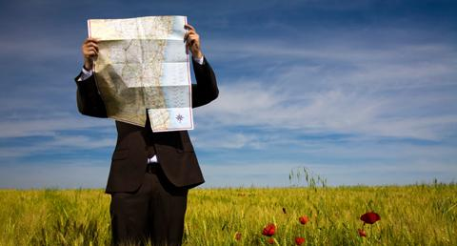
You could split the task so that each member of the team is responsible for 1 of the D’s or the members of the team with a map could, between them, identify the five D’s and then brief the whole group. At the very least the whole group need to know what you are going to see and when you are going to see it. In this way the whole group have a responsibility to point out these tick features as you progress along the route. When you get to your destination (the end of your navigational leg) you must stop and repeat the process not just continue on without forming your new strategy. You must always have a strategy.
At all times the entire team must know:
- What you are expecting to pass, cross or see.
- When you are expecting to pass, cross or see it.

3. The Compass
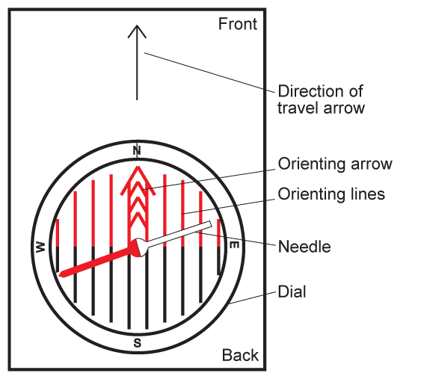
A compass can tell us which direction we are facing. It does this by use of the planet’s magnetic field. If you turned the dial of a compass so that the letter E is at the top then, turn the whole compass so that the magnetic needle is sitting in the red ‘orientating arrow’ then the ‘Direction of Travel’ arrow will be pointing East.
By convention we measure compass bearings in degrees with North at 0 º. As there are 360 º degrees in a circle that means that East is 90 º South 180 º and West 270 º. We can turn the compass to any numbered degree value in between these points.
If we are on top of a hill then we may need to work out which direction to walk off. We could look at the map and guess what angle the path we want sits at, and then set the compass to that bearing, or, if we want to be more accurate, we can use the compass as a protractor to get an exact bearing from the map.
Taking a bearing from the map:
Let’s assume we want to work out the bearing between two points so we can walk in a direct line between them.
- Make an estimate - Have a guess at the direction in which you will be walking (roughly North-East or 45 degrees in the example on the right). By making an estimate you should avoid the embarrassment of being 180 degrees out. Set your compass to this estimate now.
- Position the compass - Place the long edge of the compass along the path that you need to follow with the big (direction of travel) arrow pointing in the direction you will be walking i.e. the back of the compass should be at point A and the front at point B.
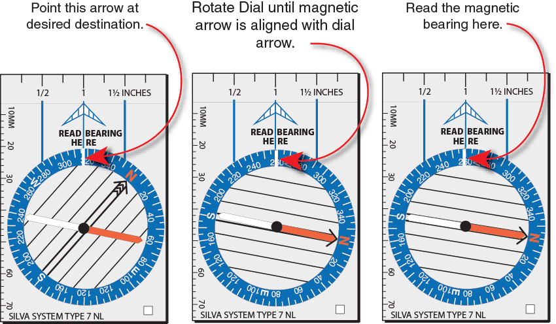
- Turn the dial - Turn the dial so the orientating arrow is pointing up the map, parallel with the grid lines (ignore the needle). You should end up with a figure similar to what you estimated in step one. If it is vastly different you are probably 90, 180 or 270 degrees out.
- Add the magnetic variation
- Align the needle - Take the compass off the map and line up the magnetic needle and the orienting arrow by holding the compass flat and turning yourself round on the spot.
- Follow the direction of travel arrow - The ‘direction of travel’ arrow will point in the direction you need to walk in

4. Magnetic variation

The compass can be seen as a tool for converting directional information from the earth to the map and vise-versa. However, with this conversion there is an error. Below is an explanation of that error, information on how to find out what that error is and how to adjust for it. Before we start there are 2 things you have to understand;
- The grid lines on the map are NOT lines of Longitude. Lines of longitude converge at the North Pole. These grid lines are exactly 1km x 1km square. Each north-south grid line therefore points to a different place and not to the North Pole.
- The magnet on the compass needle doesn’t point to the North Pole either but somewhere north of the Hudson Bay in Canada.

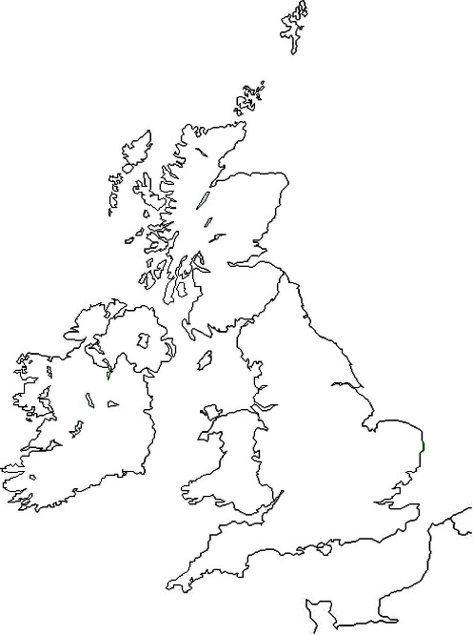
As our system of grid lines does not match up to the earth’s magnetic field, to convert from the bearing gained from the map to one that you follow on the ground you have to make an adjustment. This is the magnetic variation.
A
B
Magnetic north
Fig. 1
It gets more complicated. As each grid line points to a ‘different north’ but the needle on the compass always points to the same place, the variation is different depending on where in the UK you are. Fig. 1 shows (in a vastly exaggerated form) that if you are in the South West the magnetic variation is smaller than if you are in the North East. Angle B is less than Angle A.

It gets worse. Magnetic north is moving. Magnetic North is moving to the East and therefore the difference is declining. Back in 2004 it was 5° in Cumbria. By 2010 it had reduced to 2°.

The rule, at present, is that if you are taking a bearing from the map and going to follow that bearing on the ground you add the magnetic variation and if you are working from the ground to the map you subtract it. The easy way to remember this is that the map is a small thing and the earth is a big thing so you have to add (make the bearing bigger) when going from the small thing to the big thing. In time I expect this to be the reverse as Magnetic North passes across our grid lines.

To find out what the magnetic variation is where you are you have to look at the notes on a map. It will say something like. Magnetic north (make sure you are reading the bit about Magnetic North and not True North) is estimated at 2°24' West of grid north at the centre of the sheet for July 2009. Annual change is approximately 10' East.

5. Interpreting contours

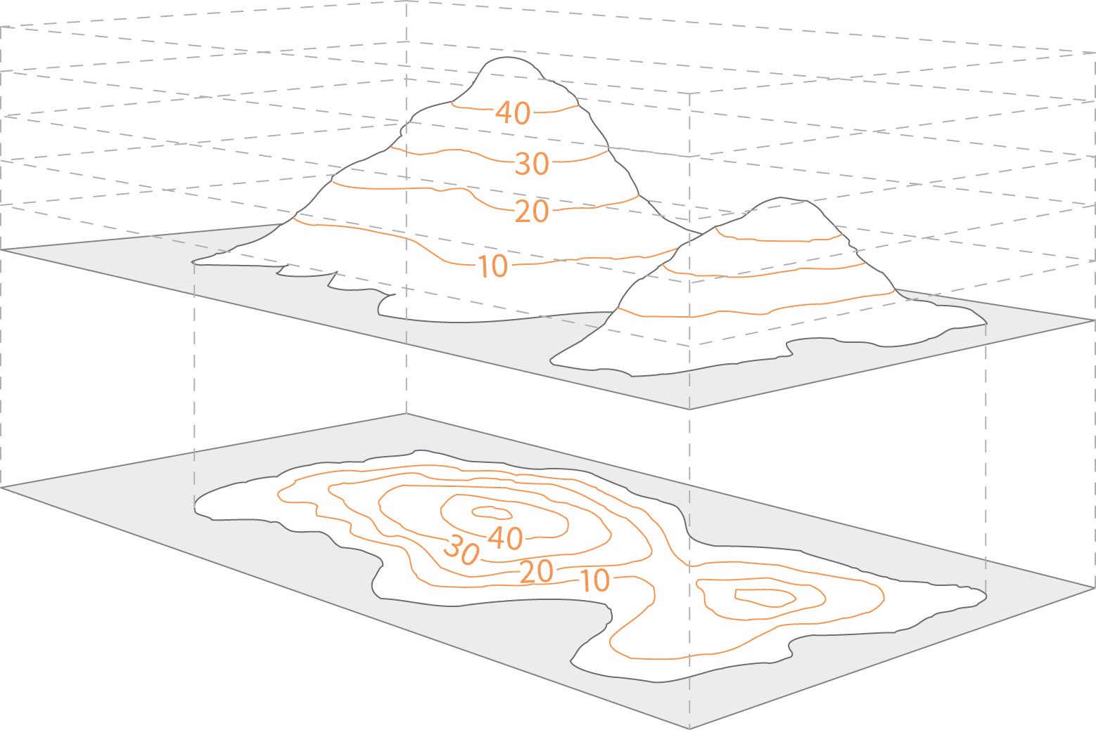

Contour lines on a map are a way of reading the height of a piece of land. Usually the space between contour lines is 10 metres. However for flatter land, usually in the lowlands, the space can be 5 metres.
Contour lines are the best navigational tool especially if you are navigating around steeper land. The closer the contour lines are together, the steeper the land, the further they are apart, the flatter the land. With this information it is easier to determine a safe and manageable route and, more importantly, easier to find out where you are.
A ring contour will mark a spot height, often known as peaks or summits. This will be a significant catchment feature and sometimes can be seen from a long distance away. If you can match these to the map you will have no trouble navigating.

6. Relocation

There will be times when you are not sure where you are. The key to good navigation is observation. When you are walking, keep looking around you. Keep a mental note of ALL tick features that you pass, not just the ones you identified from the map at the beginning of the leg.
Once you realise you are not sure where you are there are a few steps to go through.
- Stop.
Don’t look at the map yet, take a look around you to see if there are features that you will be probably be able to see on the map. A tarn or a ring contour for instance. You may be able to take a bearing on your path or down a valley.
- Where were you when you last knew where you were?
How long ago was that? What direction have you been walking in since then? How far might you have walked in that time? What have you passed since and when?
- Put all that together with what you can see on the map.
This is the tricky bit. It is a good idea to start with where you last knew where you were and work forwards following your route recalling what you passed (note: the route you took may be different from the route you were meant to take). All being well you should be able to identify your position with ease using the features you identified in step 1. Be very aware of the tendency to make things fit with what you can see when they don’t in real life. Pay particular attention to scale.
What if that doesn’t work? If you are getting nowhere you may wish to consider one of the following courses of action
- Move around a bit to see if you can see more helpful features. Don’t go far but moving a short distance will often reveal new features.
- Back tracking to a place that you knew where you were. Learning how to relocate is more about looking around you rather than looking at the map. When lost, inexperienced navigators tend to start studying the map intently looking for clues. It is easy to be 10 meters from a tarn and not be able to see it if you are slightly below it. However, if you can see a tarn on the ground (and it is big enough) then it will be on the map.
Look around first, look at the map second.

Section 2 – Route Planning

- Hazards and Route planning

It is a dangerous world out there, full of all sorts of things that are exciting, fun and can injure you. When planning your route you should be aware of potential dangers and consider ways that you can minimise risk. Some things, like farm houses with ferocious dogs, you can’t really foresee, others you may be able to identify on the map and plan your route accordingly.
Some dangers you may wish to acknowledge and go there anyway, accepting an increased risk, others you may wish to avoid completely.
- Water (streams, fords, stepping stones, lakes).
If you are crossing a stream you should use a bridge. Under no circumstances should you be wading through water. As a rule, if the water is deeper than the ankle of your boot then it is too deep. Wading through streams and rivers is never safe. You may have chosen a route that involves stepping stones, these should be treated with caution (especially when they are wet). Please don’t go swimming in rivers or lakes, even if you have done so before on your own or with your family.
- Falling down something (Shake holes, cliff s, mines).
On your map you may see cliff s, old mine workings, pot holes and areas of shake holes marked. Pay attention to these and under no circumstances decide to go exploring old mine workings.
- Roads.
Avoid roads completely if possible, they are rubbish for walking on anyway. If you do need to cross a road or walk along a road for a short period then wait for everyone to catch up and gather together. Make sure everyone knows where you are going, what tick features you will pass and roughly how long it will take. Then execute the manoeuvre, in single file, as quickly and efficiently as possible. Don’t chatter, concentrate. It is the reality that, even with all that dangerous countryside around, fast country roads and cars are probably your greatest threat.
- Trips and falls.
Wear decent boots with a decent amount of tread (to give good grip). If you are unsure on the suitability of your planned footwear seek advice from your DofE leader or supervisor. Take particular care on steep or slippery ground.
- The weather (hypothermia, lightening, flooding, hyperthermia, sunburn).
Make sure you check the weather before leaving for your expedition and pack accordingly.
- Farm animals.
Be aware of the potential dangers posed by farm animals.

2. Example route card

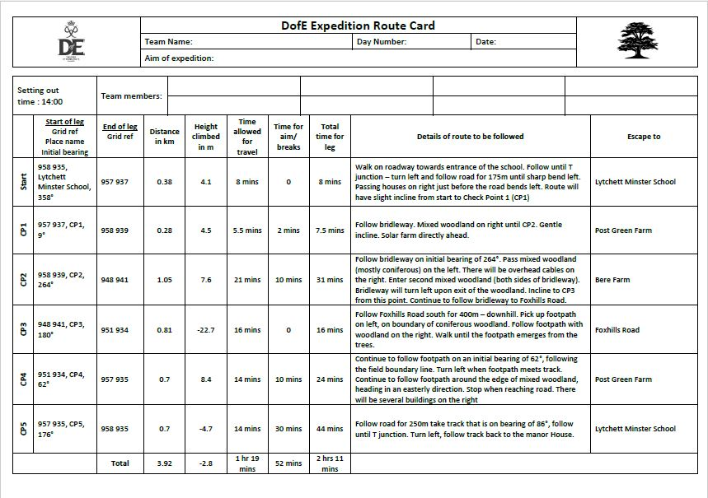

Section 3 - First Aid

- Basic First aid
With a little care the injuries below are often avoidable. Preventing them is much better than having to provide treatment. It is very rare to have a serious injury.
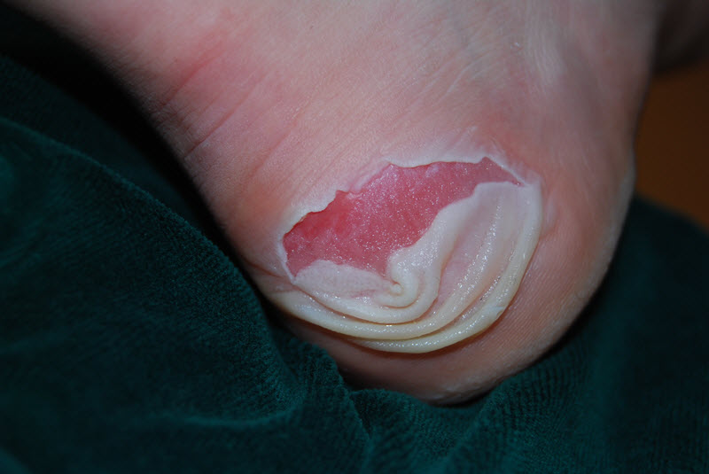
- Blisters.
These are an irritation that can stop you completing an expedition if they become serious
Prevention: Wear well-fitting boots and suitable socks, Try and keep your feet and socks dry.
Treatment: Apply a plaster, preferably a blister plaster, as soon as a sore spot develops. If a blister develops, do not burst it, but keep it covered with a blister plaster.
- Burns and Scalds
Prevention: Use stoves sensibly. No smoking or naked flames in or near the tent. Protect against sunburn.
Treatment: Run cold water over the burn for at least 10 minutes. On campsites there should be a tap, out walking you might be able to fill a bowl or a bag with water and immerse the burn in it, pour water from a bottle or dunk the affected part in a stream (if it is safe to do so). Take care not to get clothing or unaffected areas too wet (see hypothermia). Do not use ice packs on burns. After the cold water treatment cover the burn with a clean, smooth dressing. Call your supervisor immediately if you suffer a burn or scald of any size. Call 999 if a burn covers a large area, involves charring of the skin or could affect the airway.
- Breaks and Strains
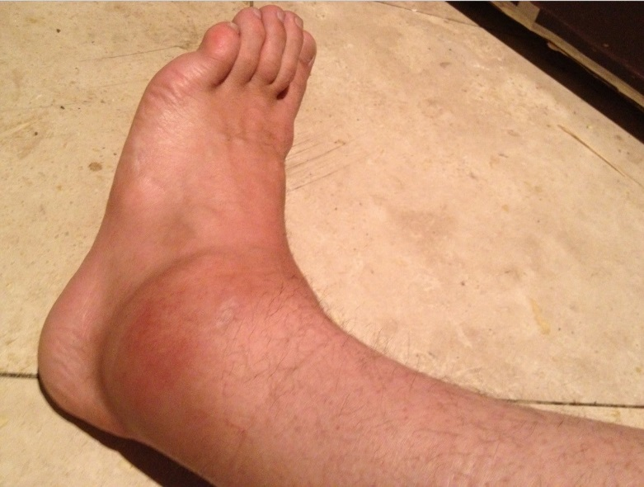
This is probably the most common type of injury, especially in the outdoors. Prevention: Wear good boots. Take special care when it is slippery, steep or uneven underfoot.
Treatment: Treat as a suspected fracture: Rest, Cool, Compress and Elevate as appropriate. Call your supervisor if you have any such injury which may make it too painful to continue. Call 999 if you suspect any break to the femur (upper leg), skull, pelvis, neck or back. First Aid Resting and cooling an ankle injury
First Aid Kits
If you are borrowing a first aid kit take a look inside before your expedition to make sure you know how to use its contents and it has everything you may need.

- Hypothermia

This is most likely in cold, wet and windy conditions. Illness and fatigue also increase the risk. Symptoms include complaining of cold, becoming less communicative, disorientation and loss of co-ordination.
Prevention: Wear warm, waterproof and windproof clothes as appropriate. Get sufficient rest and food. Early detection is important as treating mild hypothermia is quicker and easier than severe hypothermia. It is hard to detect in yourself so get into buddy pairs look out for each other, especially if the weather starts to deteriorate.
Treatment: Hypothermia can be thought of as cold exhaustion so you treat the exhaustion and treat the cold.
1) Exhaustion: Get energy in (feed with sugar), take their bag off them. 2) Cold: Keep them moving (in early stages) to generate heat, get them to shelter to remove wet clothing and replace with warm, dry clothes. If there is no shelter then pile warm, dry clothes over the top of the wet ones. If severe then put up tents and get in them. Get help.
- Heat Exhaustion
Heat exhaustion can occur due to loss of salt and water through sweating. Symptoms may include headache, dizziness, confusion, and nausea, sweating with pale clammy skin, cramps and rapid weak breathing. Prevention: Eat, drink and rest appropriately. Wear appropriate clothing. Treatment: Get to a cool place or create some shade if this is not an option. Consider splashing water on exposed skin and fanning. Drink plenty of water, preferably followed by some water with a little salt in it or flat lemonade. Call your supervisor.
- Dehydration
Symptoms include feeling thirsty, very concentrated yellow urine, tiredness, disorientation, vomiting.
Prevention: Drink plenty of water, or water with fruit juice. A good idea is to drink lots when you arrive at a campsite, and again before you leave it, as you will have plenty of water on the sites, then top up from your bottle during the day.
Treatment: Basically drink. If you are suffering severe dehydration you will need to rest and drink small amounts of water at a time to prevent more vomiting.

All first aid incidents, however small, must be reported to your supervisor. In the case of minor incidents you may wish to inform them later in the day, when you see them next, but you should call them immediately if:
- An incident is serious enough that you are unable to continue walking, or
- you have to call 999, or
- you are in doubt about whether or not you should call them.

- Ticks and Lyme disease

What is Lyme disease and what are its symptoms?
Lyme disease is an infectious disease transmitted by the bite of an infected tick. It causes a wide range of symptoms which may include a circular red “bull’s eye” rash, headaches, a stiff neck, facial palsy, extreme fatigue, muscle and joint pain, and disturbances of sight, hearing, co-ordination, digestive system and sleep.
What are ticks?
Ticks are blood-sucking arthropods related to spiders. Their initial bite does not hurt or itch because they inject an anaesthetic into their host’s skin.
Where are ticks found?
Ticks can be found all over the UK in gardens, woods, moors, and parks – London/city parks being no exception. Not all ticks carry Lyme disease.
How should a tick be removed?
Ticks should be removed as soon as possible, preferably with a tick removal tool which hooks underneath the tick and which does not risk squashing it (google ‘tick tweezers’ or visit www.tickcard. co.uk/ for bulk buy tools). In an emergency, a thread of cotton can be wound close to the skin, and pulled upwards. Disinfect the area around the bite using antiseptic cream.
How is Lyme disease diagnosed?
The symptoms mentioned above may appear between 2 and 30 days after a tick bite. Although a rash may appear quite shortly after the bite, blood tests will probably be negative initially. The rash should be treated immediately without waiting for a test result.
Can Lyme disease be prevented?
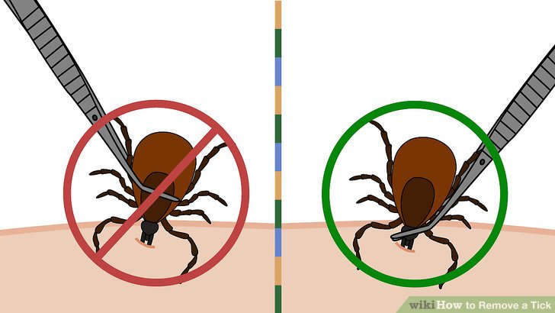
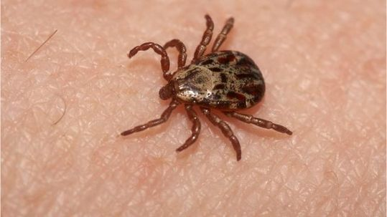
There are many measures that can be taken to protect from infection. These include wearing suitable clothing (keeping arms and legs covered, if practicable) and frequently checking the skin for ticks. It is important to know how to remove a tick properly and to seek medical advice promptly if any symptoms appear. All images and information obtained from Lyme Disease Action.

Section 4 – Emergency Procedures

- Emergency Procedures

Evaluate the situation
Apply first aid if necessary. Do you need help? If so do you need help from our staff or the Emergency Services?
If you don’t need help do you still need to try to contact your supervisor? (For instance: Are you going to be late or even not get to your campsite and just camp where you are.) If you are lost then making sure you are on a footpath (any footpath) will speed up our ability to find you. If you have made the decision to do an emergency wild camp then do all you can to make sure you do so on a footpath.
Calling the Emergency services
If you decide to call the Emergency services from your location do so by calling 999 or 112. Even if you have no signal it often still works. If you require the services of mountain rescue (i.e. if the casualty is in a remote situation) ask for the police and tell them that it is a mountain rescue situation. Be ready to tell them.
- Number and type of casualties.
- Where you are, a grid reference or as close as possible.
- What your phone number is.
- Our contact details and ask them to contact us (assuming you cannot do so yourself). As we are in the area it is entirely possible that we will be able to get to you sooner.

Sending for Help
If you do not have phone reception you may have to send part of your group to get help
- Decide where to go for help. Make sure the people staying know where you have gone. You may elect to go somewhere to find phone signal or to the nearest house.
- Write down all important information.
- Make sure there are two of you going together.
- Take enough equipment to ensure your safety.
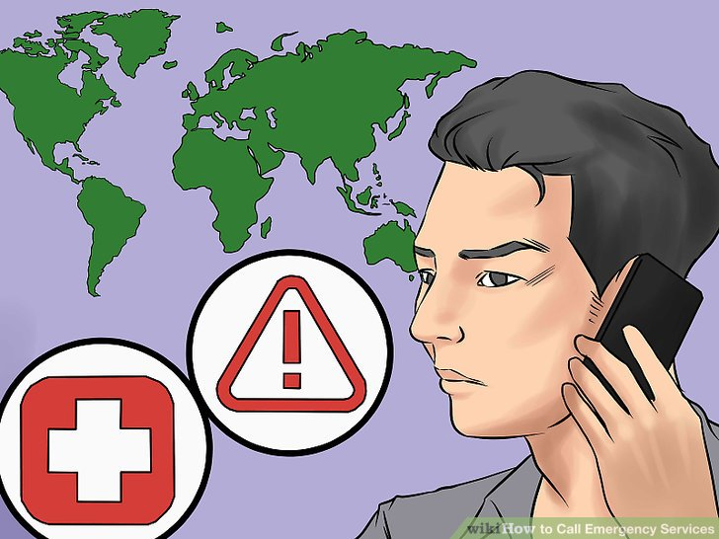
- Don’t rush.

When you get in contact with us (DofE supervisors) or emergency services get clear instruction on what to do next.

Waiting for help

Once you have decided that you need help on the hillside you need to prepare for a potentially long wait for us or the emergency services to get to you.

There is a lot you can do to make things more comfortable and to pass the time:
- Keep someone with any casualties at all times. Look specifically for signs of shock and hypothermia.
- Keep checking on each other, is everyone warm enough?
- Every few minutes blow your whistle (six long blasts).
- Consider putting up a tent or two. You will probably be in the same place for a number of hours waiting for help to arrive.
- Consider getting someone to make a brew. Hot drinks will help you keep warm and are great for morale.
- Once things have settled down and you have the time, write a log of events. Time of incident, time of phone calls, changes in casualty condition, first cup of tea, tents up. It will help you keep time in perspective.

Section 5 – The countryside code

- Countryside code

The countryside is vulnerable to overuse and misuse by those of us who visit it. By taking a few precautions and following some common sense rules we can drastically minimise our impact on the environment.

- Don’t drop litter. By litter we include not just paper and drinks bottles but also organic material such as orange peel and banana skins. These materials may take weeks or even months to rot down and look unsightly while they do.
- Take care on roads. Many country roads are narrow and cars often travel very fast on them. When you get to a road, stop. If you are navigating brief the rest of the group on how far you will be walking and where you will be turning off. Then lead off walking in single file. Generally you should walk on the right hand side of the road. However, if the road is very narrow it may be safer to cross to stay on the outside of any bends. Please concentrate and don’t chatter to each other until you are safely off the road.
- Leave gates as you find them. If you open a gate make sure you close it properly behind you or livestock may escape. If a gate has been left open then it is probably a good idea to leave it that way unless it is obvious that it has been done so through the carelessness of others and leaving it open may endanger people or livestock (a field of cows next to a road for example).
- Don’t go to the toilet close to streams, lakes or any other watercourse. Ensure you are at least 30 metres from any watercourse before going to the toilet. If you need to poo ensure that it is well buried (at least 15 cm deep). It is a good idea to burn any toilet paper then if it does get dug up by an animal there is not dirty toilet paper blowing about. If you can’t bury it then current advice is to spread it out as thinly as possible (you could use a rock) to speed up its breakdown. Sorry... I don’t make the rules.
- Think about erosion. If you are on a thin footpath through a meadow (for example) then walking in single file on the path will cause less damage to the area than spreading out next to each other. Most footpaths are wide enough for two but if they are not then please don’t widen them.
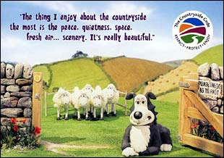
- Take care around animals. This is especially true if they have young with them, this is as much for self-preservation as animal welfare. It is not a good idea to walk between a cow and its calf. Leave the footpath to go round them rather than creating this scenario.
- Don’t wash up in streams. If you cook close to a stream then please don’t pollute the stream by washing up in it. If you need to wash up, fill a pan from the stream and take it away from the stream to do the washing up and pour the waste water into the ground.

Section 6 – Kit and packing

- Kit List

Clothing
Got it | Packed it | Item Needed |  | Reccommended
 |  | 1x Pair of walking boots (broken in) |  | Berghaus: Explorer Trek and Explorer Ridge boots
 |  | 2x Pairs of walking socks |  | Bridgedale: WoolFusion Trekker, WoolFusion Trekker women’s, Woolfusion Trail, WoolFusion Trail women’s
 |  | 2-3x t-shirts |  | Craghoppers: Fusion and Vitalise Base T-shirt
 |  | 1x Thermal t-shirt (optional) |  | Craghoppers: Fusion and Vitalise Base T-shirt
 |  | 2x fleece tops |  | Craghoppers: Fleece: Vector and Ionic Hooded Jackets, Vector and ionic half zip tops
 |  | 2x Walking trousers (not jeans!!) |  | Craghoppers: Traverse Trousers
 |  | Underwear
 |  | Nightwear
 |  | 1x pair of Flipflops/trainers/sandals (for walking around camp/showering)
 |  | 1x warm hat and or sunhat (as appropriate)
 |  | 1x pair of gloves (if appropriate)
 |  | 1x pair of shorts (if appropriate)
 |  | 1x Water-proof over trousers |  | Craghoppers: Ascent Overtrousers
 |  | 1x Jacket/coat |  | Craghoppers: Waterproof Shell: Reaction Lite and Apex Jackets
 |  | 1x pair of gaiters (optional)
Personal Kit
Got it | Packed it | Item Needed |  | Reccommended
 |  | 1x Rucksack 65-75L |  | Vango: Contour, Sherpa, Pinnacle rucksacks
 |  | 1x Rucksack liner or black sack
 |  | 1x Sleeping bag |  | Vango: Nitestar, Latitude, Venom, Ultralite, Ultralite Pro and Stratos (Cotswold Outdoor exclusive) sleeping bags
 |  | 1x Sleeping mat |  | Vango: Single Adventure and Trek mats
 |  | 5x waterproof bags/dry bags |  | Lifeventure: Dry Bags and Compression Bags
 |  | 1x Sleeping bag liner (optional)
 |  | 1x Whistle
 |  | 1x torch (handheld or headtorch and spare batteries) |  | Lifesystems: Intensity 220 torch, Intensity 220 head torch
 |  | 1x personal first aid kit |  | Lifesystems: Camping first aid kit, Trek first aid kit, Blister first aid kit, Waterproof first aid kit.
 |  | Expedition food *see nutrition section
 |  | 1x Water bottle |  | Lifeventure: Tritan Flask (1000ml), Tritan Bottle (650ml)
 |  | 1x knife/fork/spoon (or spork) |  | Lifeventure: Basic knife fork and spoon set, Ellipse knife, fork and spoon set
 |  | 1x plate/bowl |  | Lifeventure: Stainless steel camping bowl, camping plate, Titanium plate, Ellipse plate, Ellipse bowl
 |  | 1x Mug
 |  | 1x Box of matches
 |  | Wash kit/personal hygiene items
 |  | Sunblock
 |  | 1x Small travel Towel
 |  | 1x Notebook/pencil
 |  | Watch
Group Kit
Got it | Packed it | Item Needed |  | Reccommended
 |  | Tent(s) - provided
 |  | Camping Stove(s) - provided
 |  | Camping gas - provided
 |  | Cooking pans - provided
 |  | Scourers - provided
 |  | Tea towels - provided
 |  | Pastic bags (for rubbish)
 |  | Toilet paper
 |  | Maps 1:25,000 - provided
 |  | Compass |  | Silva: Classic, Field, Ranger, Expedition 4 compass.
 |  | Map case |  | Silva: Carry Dry Map Cases – A4, M30 and Large.
 |  | Camera (optional)
Got it | Packed it | Item Needed |  | Reccommended
 |  | Hydration pack |  | Vango: 2L Hydration pack
 |  | Boil in the bags |  | Wayfarers ready meal packs
 |  | Insect repellent
 |  | Sunglasses
 |  | String
 |  | Spare boot laces
 |  | Playing cards/games for downtime
 |  | Water purifying tablets

- Packing a rucksack

Much of packing a rucksack is down to personal preference. Here are some things to bear in mind which should make life easier and load carrying easier. There are two basic principles that you will want to follow when packing your rucksack, unfortunately the two principles sometimes conflict but do your best.
Principle 1: Heavy items should be close to your back, evenly weighted (side to side) and near the top. This means you won’t feel like you’re being pulled off balance. It will also reduce the amount of pull on your shoulders. For instance, Place a heavy item like your tent under the lid rather than on the straps on the bottom at the back.
Principle 2: Items you may need should be accessible. Pack your snacks, lunch, drinks, waterproofs, hat, gloves, torch and emergency gear near the top of the bag or in the outer pockets.
Other considerations, tips and tricks
- The Sleeping bag - It is common to pack the sleeping bag at the bottom of the rucksack. It is the least likely item to be needed during the day and if your sleeping bag is at the bottom you know you can sit on the bottom of your rucksack without splitting food bags open or breaking anything.
- Keeping things dry - Everything in your rucksack should be in waterproof bags! You could use a big waterproof liner inside your rucksack (heavy duty rubble sacks or bin bags are good cheap options) or you could put everything in lots of smaller carrier bags. Your sleeping bag stuff sack is not waterproof so that needs to be inside a bin liner too. Do not just rely on the rain cover as it will fail.
- Attaching things to the outside of the bag - As sleeping mats are so light they can be attached by straps to either the top, side or bottom of the bag as preferred. It is best not to attach anything else to the outside of the bag - heavier items will make the load unbalanced and smaller items might get lost or damaged. You also look a lot more slick and together if you haven’t got a pair of flip flops or a mug hanging off your bag.
- Fitting your rucksack - Make sure your rucksack is correctly adjusted to you. You can adjust the back length, the shoulder straps and the position of the hip belt. It will make a huge difference to how the weight is distributed and when you get it right, it will actually feel lighter. Get used to the routine of adjusting your pack every time you put it on and you will feel the benefit. When putting your rucksack on avoid picking it up by one strap and swinging it onto your back as you may damage the rucksack and your back. Help each other out by lifting each other’s bags up while you put them on.

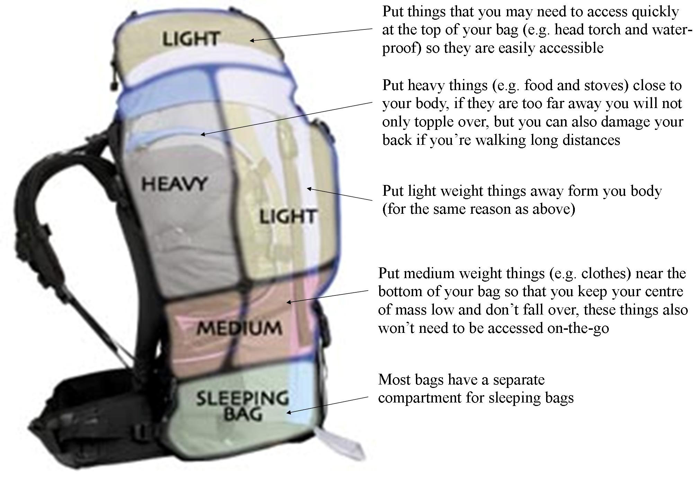

Apart from a roll mat, everything should be inside the rucksack. There’s is always a high possibility that equipment attached to the outside of the bag will either get lost or damaged.
Aside from this it can be very annoying and unbalancing having things swinging off the bag of your pack.

Section 7 – Campcraft

- Looking after your tent

The popularity of festivals and the cheap ‘disposable‘ tent has meant that many people don’t know how to look after them properly. Our tents are used as much high up in the mountains in foul weather as they are in the sheltered valleys. They should be thought of not merely as tents but expensive and important emergency equipment. While you may be camping on a campsite in the Dales in August the next time your tent is used it may be in gale force winds on a mountain in a Scottish winter. Treat it well.
- Before pitching - Check the site for stones and sharp twigs. These will not only make your night more uncomfortable but may puncture the groundsheet and then let water in.
- Don’t lose the bags. As soon as you take the tent, poles or pegs out of their bags put the bags in your pocket so they don’t blow away. Once the tent is up put all these bags inside the tent.
- Keep your tent clean. Take your shoes off, try not to get mud on the side of the tent. Always tie back the doors when they are open. If a tent gets dirty this negatively effects its waterproofing.
- Use the zips. If you open the tent by simply pulling on the material this will weaken the zips and may cause them to break. If your zips break you may be in for an uncomfortable night.
- Allow the tent to ventilate. If your tent has solid inner walls then it is important to keep the inner door open a little. If you don’t then condensation from your breath will collect on the walls and make the inside of the tent, you and your sleeping bag damp. Even if it is cold a small gap will keep you dryer and therefore warmer.
- Don’t smoke or cook in or near the tents. A tent can catch fire in seconds burning anyone or anything inside it. Do not under ANY circumstances cook or smoke in the tents.
- Dry the tent when you get home. ALWAYS take the tent out of its bag and hang it up to dry when you get home (even if you think it is dry). If you don’t hang it up to air, it will rot and need replacing.
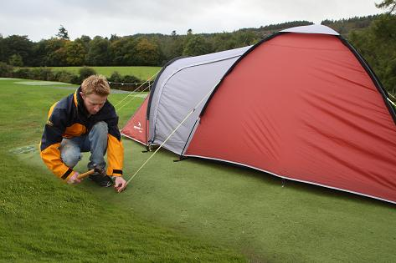

- Campsites

Campsites vary a lot; some have games rooms and cafes, others may be just a corner of a field with perhaps a toilet and cold tap in a nearby farmyard. Most are somewhere in between.

Arriving on Site
The first thing to do is usually to find the campsite owner to say hello, find out where to camp and where the various facilities are (toilets, washing up, showers: if you are lucky). After this there are 2 main things that always need doing.
They are: putting up the tents, and cooking food. Some groups prefer to do one then the other but it is usually better to do both at the same time. Some of the group can put up the tents while the rest start preparing the meal. If anyone is feeling cold, tired or hungry then a good idea is for them to have a snack straight away.

Establishing Camp
First, choose exactly where in your area your tent should go, you should consider: • Shelter. If it is very windy you may want to try and pitch out of the wind for a better night’s sleep. • Other campers. Try and keep a reasonable gap between you and others. • Slope. Try and find flat ground, if you can’t then you will probably want to turn your tent so your head will be up hill. • Ground conditions. You will want to avoid boggy areas or areas that may flood. Your tent instructions might tell you which end to pitch into the wind. If in doubt pitch it with the door facing away from the wind. Make sure that anything that could blow away is secured. Put simply don’t put anything down and don’t unpack your rucksack outside of your tent. As soon as your tents are up get a rubbish bag sorted and then don’t put any litter on the floor, you’ll only have to pick it up again.

While on the site
On some expeditions (gold especially), by the time you have put your tents up and eaten you will be ready for bed. Other times groups have taken cards, books, Frisbees etc. to give them something to do. It is a good idea to review the next day’s walk at this time, you might also want to work on your aim/presentation while the group is all together.

Striking Camp (AKA packing up)
Striking camp can sometimes be more challenging than it sounds, especially if the weather is bad. It is a good idea for the whole group to get up at the same time, have breakfast and then all pack up together. To help, try to get as much as possible ready the night before; leaving only the essentials for preparing breakfast and the last bit of packing for the morning.
Once your group is ready to leave, do a litter (and food waste) sweep of the area where you camped, where you cooked and downwind of these areas if it has been windy. Assessors will visit campsites after you have left to check that they are litter-free.

- Wild Camping

At gold level, some expeditions involve one or more wild camps on moorland or in the mountains. This is not a requirement of the award but is chosen by some groups who want the increased solitude and remoteness of a wild camp. Wild camping involves extra challenges in planning, organisation and staying safe, but it is worth it.
Planning to wild camp
In England and Wales there is no legal right to wild camp (except on Dartmoor) so for the DofE you need to gain permission from the landowner. In Scotland you can camp in remote areas provided that you camp on land that is not used for any other purpose.
Your DofE supervisor will advise on whether wild camping is a realistic option for your expedition and on possible places to camp. You can also gain useful info from the map; look for somewhere with a water source and the likelihood of a flat, non-boggy, spot. Wild campsites should be off the beaten track on remote hills over 600m, groups should be kept small and tents preferably of an unobtrusive colour. When you get to your spot you may have to change your plans if the planned campsite is not suitable.
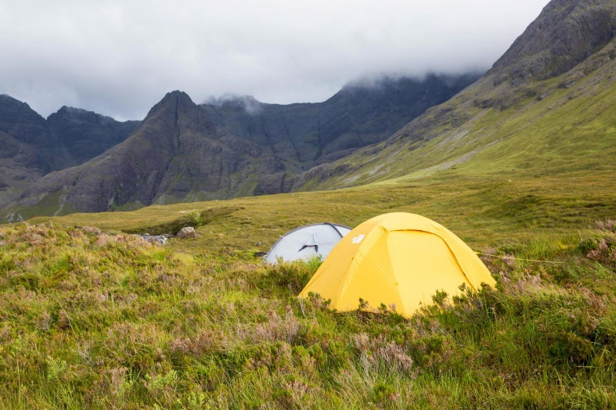
You should be aware that it is often colder, windier and wetter in the mountains than in the nearby valleys; your tents, sleeping bags and clothing will need to be up to the task.

When you arrive
Identify a good water source and also a suitable place for a latrine (see the country code page for advise on going to the toilet). While it is light your group should have a little explore to identify any hazards in the area (steep drops, deep pools etc.) and to see if you have phone signal anywhere nearby in case of emergency. Try to avoid trampling plants and moving rocks. Take all your litter and food scraps away and definitely don’t light any fires. When wild camping you should follow a ‘Leave no Trace’ policy.

Getting water
You will probably need to collect water from a stream, for the evening, the next morning, and to take on the next day’s journey. You might want to take equipment for purifying it, such as tablets or an ultraviolet purifier. Clean water is a valuable resource relied upon by many people living in the mountain regions. Contaminating the water with soap, washing up liquid, insect repellent etc, could kill local insect and plant life. Do not wash up or wash yourself in streams and dispose waste water well away from water courses (use eco-detergents). Enjoy it! Wild camping is a unique way to experience being in some amazing places, and quite often to have the place to yourself after everyone else has gone home for the day. DofE expeditions are about solitude and independence, and you don’t get much more of these things than when wild camping.

- Gas trangia use

- Never use the stove within 3 metres of any tent.

- Set up the trangia - Thread the pipe through the hole in the top of the base and out the side as shown (Right). Ensure the burner is properly seated or the fuel pre-heater pipe can melt your pans

- Attach the gas - With all gas stoves using fuel of this type ensure that you do not ‘cross thread’ the burner when screwing the burner onto the gas.

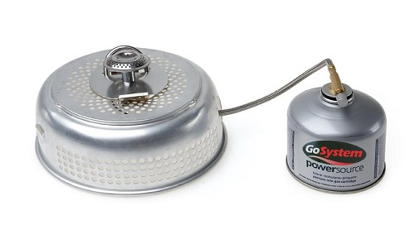
- Smell for gas - 10 seconds after attaching the burner to the canister. Do not light the burner until you have done this check. If you do miss this step then you may end up with a burning jet of gas escaping between the canister and the connecting pipe with no way of turning it off. If you do smell gas check that the valve is off and it is not cross threaded, then try to tighten the seal. If you cannot make a good seal then try a different canister. While all types of stove should fit on all brands of this type of gas canister some do not. Check that your gas canister works with your burner before your expedition.

- Keep the gas canister upright - If your canister falls over then liquid fuel can enter the pipe and cause flaring.

- Use the handle - to hold the pan when stirring. (Though don’t leave the handle on the pan). Holding the handle provides stability while stirring but if you leave the handle on the trangia it can get very hot.

- Disconnect the gas canister - When you have finished cooking, turn off the gas nd then disconnect the burner from the canister.

Section 8 - Nutrition

- Expedition menu - in principle

When out walking, particularly on multi-day trips, it is important to make sure you eat enough to prevent exhaustion and the associated problems and dangers.
There are a few things to consider when menu planning. As usual some of these factors conflict with one another so it is up to you to consider what is best for you.

- Weight. You have to carry everything you eat once you get going, it is obviously in your best interest to make it as light as possible. You shouldn’t really consider taking tins or glass jars, However if you really, really like sardines and you know it will just make your day to have a tin then I suppose you could. Boil in the bag is heavier than dehydrated food. Think about removing excess packaging but be careful not to remove cooking instructions you may want to refer to later.

- Speed and ease of preparation. If the weather is nice you may want to spend a bit of time relaxing on the campsite and cooking. If, however, it has been raining all day the last thing you are going to want to do is sit outside in the rain cooking. Boil in the bag may be heavier than dried food but it is faster, easy to prepare and generally tastes better. If you are buying pasta choose quick cook varieties, this will save both time and fuel. Consider practising cooking what you are going to cook at home on one hob.

- Tastiness and variety. You need your diet to be as varied as possible as eating the same thing every day can become really dull. I would try and get some fresh stuff in for the beginning of the trip and move onto the less tasty but longer life foods later.

- Durability and longevity. You need foods that will not be ruined or taste bad if they are squashed and won’t leak out of any containers. If you have perishables make sure you are planning to eat them early and that you have a non-perishable equivalent for later in the expedition.

- Calorific intake. On expedition you will burn many more calories than usual. You should be aiming to eat something in the region of 3500 calories per day but this will vary from person to person.

- When you get to the campsite. When you get to the camp site you want to be eating as soon as possible. Have a snack as soon as you stop. Energy is replenished in the muscles much more effectively straight after exercise so eating immediately will give you more energy the next day. Next get your tent up in case it starts raining then start cooking your main meal.

- Emergency rations. Don’t eat all your food on the last day. You must keep some back in case of emergency. Your assessor may well ask to see your emergency rations at the end.

- Expedition menu – In Practice
- Breakfast - You won’t have to carry your first breakfast so make it a BIG breakfast. Consider going to cafe near your start point as a team building exercise. After that go for cereal, sweet porridge, flapjack or anything high in energy from your lunch stash as lunch foods and breakfast foods are pretty much interchangeable. Early in your trip croissants are great as they are full of fat and it doesn’t matter if they get squashed but eat them quick as they will go stale. Make sure you are fully re-hydrated before you leave the camp each morning as anything you drink now you won’t have to carry.

- Snacks / Lunch - Lunch shouldn’t be an event but more a process. Eat little and often. Keep food in your pockets and snack throughout the day. Good snacking foods include packets of peanuts or fruit and nut mix, flapjack, energy bars, cereal bars. If you stop for food some suggestions are oat cakes and pate (from a toothpaste like tube), heavy, stodgy cakes (for example Fruit cake, malt loaf, Jamaica cake), If you want to eat bread products choose flat bread like pitta bread or even tastier and longer lasting, tortillas. Health food shops do loads of different dried fruits. You can get a dozen dried bananas in a pack about the size of a fist. Dried fruit is healthier and provides a slower release energy than chocolate and is pretty indestructible. Everyone should get into dried fruit for their expedition.

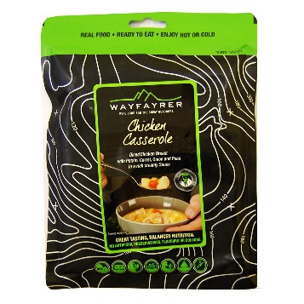
- Dinner - You want to get eating complex carbohydrate as soon as possible so skip your starter and get straight onto the main course. Noodles, pasta and rice all make good dinners, they are light weight, quick and easy to cook. They can be supplemented with other ingredients such as nuts, the odd carrot and packet sauces.

Many people choose boil in the bag foods. You can get a wide variety from outdoor shops and if you like curries you can get much cheaper and tastier ones from continental supermarkets. They are ready in minutes, create no washing up, generally taste pretty good and leave you with a pan of hot water to make a hot drink or soup with. The down side is that they are heavier to carry than dried foods. After you have eaten your main course consider going back to your starter and making a cup-a-soup. Then you will be ready for desert.

- Drinks - It is essential to drink enough to avoid dehydration. Drinking enough water is possibly the simplest way to do this. Weak solutions of cordial are also good.

- Expedition menu plan

 | Breakfast | Lunch | Dinner
Day 1
Day 2
Day 3 |  |  | Gold only
Day 4 | Gold only | Gold only

20 conditions of the Duke of Edinburgh Award Scheme

Planning the expedition
1. The team must plan and organise the expedition; all members of the team should be able to describe the role they have played in planning.
2. The expedition must have an aim. The aim can be set by the Leader at Bronze level only.
3. All participants must be within the qualifying age of the programme level and at the same Award level (i.e. not have completed the same or higher level of expedition).
4. There must be between four and seven participants in a team (eight for modes of travel which have tandem).
5. The expedition should take place in the recommended environment.
Bronze: Expeditions should be in normal rural countryside – familiar and local to groups.
Silver: Expeditions should be in normal rural, open countryside or forest – unfamiliar to groups.
Gold: Expeditions should be in wild country (remote from habitation) which is unfamiliar to groups.
6. Accommodation must be by camping or other simple self-catering accommodation (e.g. camping barns or bunkhouses).
7. The expedition must be of the correct duration and meet the minimum hours of planned activity.
Bronze: A minimum of 2 days, 1 night; 6 hours planned activity each day.
Silver: A minimum of 3 days, 2 nights; 7 hours planned activity each day.
Gold: A minimum of 4 days, 3 nights; 8 hours planned activity each day.
8. All expeditions must be supervised by an adult (the Expedition Supervisor) who is able to accept responsibility for the safety of the team.
9. Assessment must be by an accredited Assessor. At Bronze level only, the Assessor may also be the Expedition Supervisor.
10. Expeditions will usually take place between the end of March and the end of October. They may take place outside this period, if so, non-camping accommodation options should be considered.

Training and practice
11. Participants must be adequately trained to safely undertake a remotely supervised expedition in the environment in which they will be operating.
Bronze: Teams must complete the required training.
Silver: Teams must complete the required training and a practice expedition of a minimum 2 days, 2 nights.
Gold: Teams must complete the required training and a practice expedition of a minimum 2 days, 2 nights.

During the expedition
12. All expeditions must be by the participants’ own physical effort, without motorised or outside assistance. Mobility aids may be used where appropriate to the needs of the participant.
13. All expeditions must be unaccompanied and self-sufficient. The team must be properly equipped, and supervision must be carried out remotely.
14. Teams must possess the necessary physical fitness, first aid and expedition skills required to complete their expedition safely.
15. Groups must adhere to a mobile phone use policy as agreed with their Expedition Supervisor and Assessor. This agreement should also include use of other electronic equipment.
16. Participants must behave responsibly with respect for their team members, Leaders, the public and animals.
17. Groups must understand and adhere to the Countryside /Scottish Outdoor Access, Highway and Water Sports Codes (as appropriate).
18. Participants must plan an appropriate expedition menu, including cooking and eating a substantial hot meal on each day. This is optional on the final day.

Post expedition
19. Participants must actively participate in a debrief with their Assessor at the end of the expedition.
20. At Silver and Gold level, a presentation must be prepared and delivered after the expedition.
You can download a PDF version of the 20 Conditions of the Expedition section here.

The conditions that you may be most interested in are coloured in red.

